## **Number System**

### Number System | Conversion

Number System is used to convert the number from one number system to another number system, it uses a base or radix to represent.

Or

A number system is a method to represent numbers mathematically. It can use arithmetic operations to represent every number uniquely. To represent a number, it requires a base or radix.

There are four common types of number system are-

1. Decimal number system or Base 10 number system
2. Binary number system or Base 2 number system
3. Octal number system or Base 8 number system
4. Hexadecimal number system or Base 16 number system

**Number System Conversion Methods**

A number N in base or radix b can be written as:

(N)b = dn-1 dn-2 -- -- -- -- d1 d0 . d-1 d-2 -- -- -- -- d-m

In the above, dn-1 to d0 is the integer part, then follows a radix point, and then d-1 to d-m is the fractional part.

dn-1 = Most significant bit (MSB)   
d-m = Least significant bit (LSB)

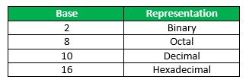

**1. Decimal to Binary Number System**

To convert from decimal to binary, start dividing decimal number by 2, and whatever the reminder getting, writing down from bottom to top, and that will be the binary number representation of the decimal number. And the number contains fractional part, then multiply 2 in the fractional part.

**Example**

(10.25)10

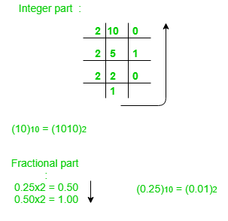

**Note:**Keep multiplying the fractional part with 2 until decimal part 0.00 is obtained.   
(0.25)10 = (0.01)2

**Answer:** (10.25)10 = (1010.01)2

**2. Binary to Decimal Number System**

To convert from binary to decimal, start multiplying the exponent of 2 with each digit of the number in decreasing order. If the number contains fractional part, then will divide it by the exponent of 2.

**Example**

(1010.01)2   
1x23 + 0x22 + 1x21+ 0x20 + 0x2 -1 + 1x2 -2 = 8+0+2+0+0+0.25 = 10.25   
(1010.01)2 = (10.25)10

**3. Decimal to Octal Number System**

To convert from decimal to octal, start dividing decimal number by 8, and whatever the reminder getting, writing down from bottom to top, and that will be the octal number representation of the decimal number. And the number contains fractional part, then multiply 8 in the fractional part.

**Example**

(10.25)10   
(10)10 = (12)8   
Fractional part:   
0.25 x 8 = 2.00

**Note:** Keep multiplying the fractional part with 8 until decimal part .00 is obtained.   
(.25)10 = (.2)8

**Answer:** (10.25)10 = (12.2)8 

**4. Octal to Decimal Number System**

To convert from octal to decimal, start multiplying the exponent of 8 with each digit of the number in decreasing order. If the number contains fractional part, then will divide it by the exponent of 8.

**Example**

(12.2)8  
1 x 81 + 2 x 80 +2 x 8-1 = 8+2+0.25 = 10.25   
(12.2)8 = (10.25)10

**5. Hexadecimal to Binary Number System**

To convert from Hexadecimal to Binary, write the 4-bit binary equivalent of hexadecimal.

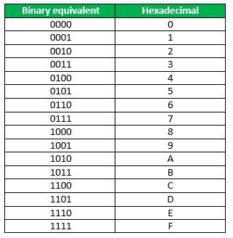

**Example**

(3A)16 = (00111010)2

**6. Binary to Hexadecimal Number System**

To convert from Binary to Hexadecimal, start grouping the bits in groups of 4 from the right-end and write the equivalent hexadecimal for the 4-bit binary. Add extra 0’s on the left to adjust the groups.

**Example**

1111011011  
0011 1101 1011  
(001111011011 )2 = (3DB)16

**7. Binary to Octal Number System**

To convert from binary to octal, start grouping the bits in groups of 3 from the right end and write the equivalent octal for the 3-bit binary. Add 0’s on the left to adjust the groups.

**Example**

111101101

111 101 101

(111101101)2 = (755)8